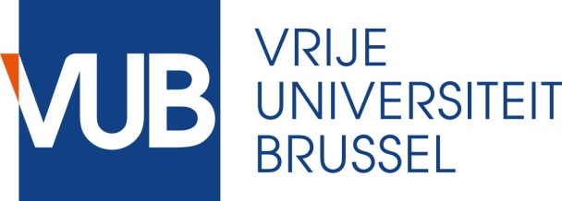
APPLICATION Exemption Compulsory Doctoral Training Programme

As of 2019-2020 the doctoral training programme is a compulsory part of your PhD. This means you need to meet to criteria of the programme before you can submit your thesis. More information about the conditions can be found on our website. If you want to apply for an exemption of this compulsory part, please state if you meet one of following criteria:
- Joint PhD, VUB is not the main institution
- Sandwich PhD (Doing your PhD minimally 50% outside of Belgium in your home country)
- Minimally 50% working in non-research function
- Other
Please send this document to doctoral.schools@vub.be for further follow-up and by 31/3/2020 at the latest.
Short Statement:

APPROVAL SUPERVISOR*  Name: ………………………………………………………………  Department: …………………………………………………….  Date: ………………………………………………………………..  Signature: | SIGNATURE DOCTORAL CANDIDATE  Date: ………………………………………………………………..  Signature:

If you don’t have a signed contract yet, add proof that you started the procedure (email of jointphd office VUB)
Add in the statement your home country and what periods you expect to be in Belgium
Add in the statement your current position, company/organization and how you combine this with your PhD
Only exceptional cases will be taken into consideration by the Steering Committee of the Doctoral Schools

